WAWA Shortie Hoagie Voucher
Fall Fundraiser
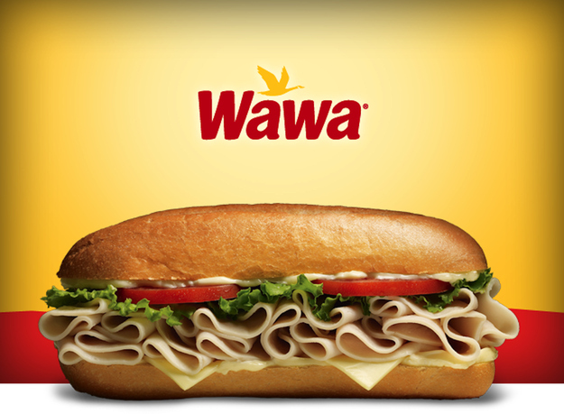
Place an order for Wawa Shortie Hoagie Vouchers today!! Each $4.00 voucher sold provides a $1.00 profit to the PJP Athletic Club. The PJPAC supports all PJP athletes and athletic programs. Simply complete the order form below and return it to your coach or the Main Office of the school in an envelope labeled “PJPAC WAWA Shortie Fall Fundraiser.” Orders are filled continuously. Please include cash or check made payable to “PJP II High School”.
_ _ _ _ _ _ _ _ _ _ _ _ _ _ _ _ _ _ _ _ _ _ _ _ _ _ _ _ _ _ _ _ _ _ _ _ _ _ _
Student Name: _____________________________
Sports team:_______________________________
Number of vouchers _________ X $4.00 = Total Due $_________
E-Mail: __________________ Contact phone # _________________

