WAWA SHORTIE SALE
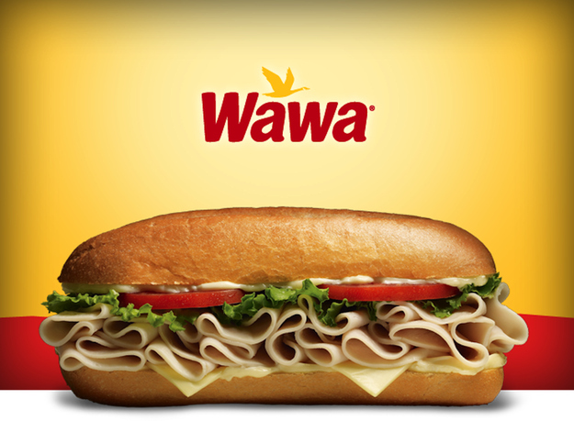
Shortie Vouchers make a great stocking stuffer and gift idea for all those who provide service throughout the year – mail carriers, bus drivers, trash collectors & babysitters. The sale is sponsored by PJPAC which supports all PJP athletes and athletic programs. Complete & return the order form below to PJP’s Main Office in an envelope labeled “WAWA Shortie Sale” by Friday, Dec. 6th. Please include cash or check made payable to “PJP II High School”. Each voucher is $4.00 ( a .69 cent savings over store price).
-----------------------------------------------------------------------------------------------------------------------------
Student Name: _____________________________
Student lunch period:___________
Number of vouchers _________ X $4.00 = Total Due $___________
E-Mail: __________________ Contact phone # _____________________

